Weekly Report

Tengteng Tao

2019/07/14

Goal:

1. Applying Yu Xiang’s parameters in my program and fit the data for material MoS2 with an unknown Kperp at the azimuthal angle equal to 34.2 degrees.
2. Using Yu Xiang’s parameters as the initial guesses and iterating based on those parameters to fit the whole data set.
3. Plotting the HWHM values for the central peaks vs. the azimuthal angles.

Plot:

Overall fitting result:

For material MoS2at azimuthal angle equals to 34.2 degrees with an unknown Kperp.

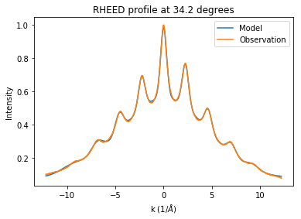

Separate peaks:

For material MoS2at azimuthal angle equals to 34.2 degrees with an unknown Kperp.

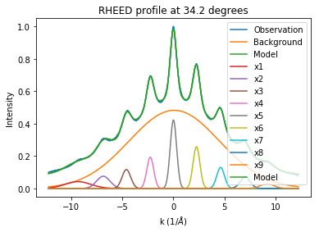

After correction, both the overall and separate fitting results are reasonable.

This table contained all the parameters after fitting:

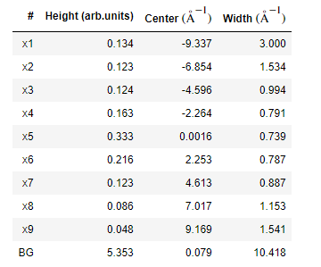

Offset = 0.0785

After getting this fitting result, I used those parameters as the initial guesses and iterated based on those parameters. Here is the result I got after running the fitting program over the whole data set:

Cartesian coordinates:

For material MoS2with an unknown Kperp.

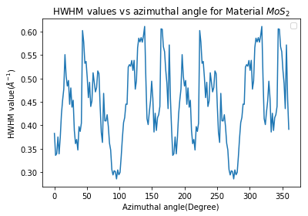

Polar coordinate:

For material MoS2 with an unknown Kperp.

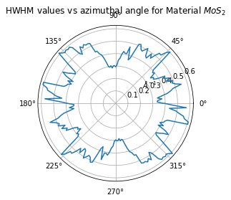

I also plotted the HWHM values vs. Kpara for each angle and found that most of the data set can be fitted with a reasonable result.

For example:

For material MoS2at azimuthal angle equals to 23.4 degrees with an unknown Kperp.

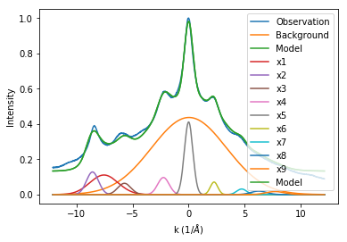

For material MoS2at azimuthal angle equals to 0 degrees with an unknown Kperp.

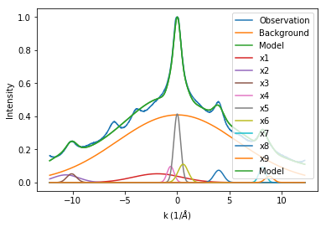

For material MoS2at azimuthal angle equals to 41.4 degrees with an unknown Kperp.

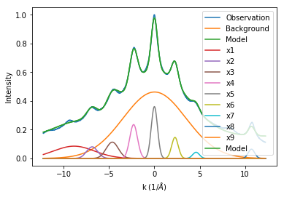

For material MoS2at azimuthal angle equals to 163.8 degrees with an unknown Kperp.

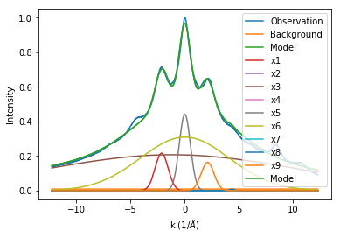

Most of the fitting results are reasonable, but there are still exist some angles with bad fitting results.

For example:

For material MoS2at azimuthal angle equals to 160.2 degrees with an unknown Kperp.

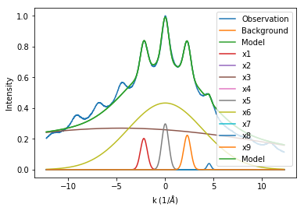

In this one, peaks located in the negative x-axis did not get a good fitting result.

For material MoS2at azimuthal angle equals to 95.4 degrees with an unknown Kperp.

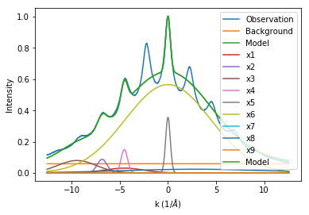

For material MoS2at azimuthal angle equals to 84.6 degrees with an unknown Kperp.

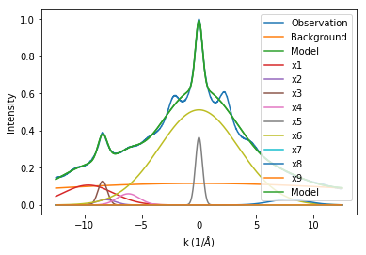

In these two plots, the overall fitting result did not show high accuracy.

Conclusion:

After my observation, I found that all the central peaks in the whole data set can be fitted well, but around 10 percent of angles have overall fitting results with relatively low accuracy. I think the possible reason for the overall bad results is that I only ran the fitting program about ten times for each angle and I believe if I ran the program fifty times for each angle, the fitting result would be better. However, running fifty times for every single angle means that the fitting job for the whole data set need about ten hours to be finished, and I am working on it right now.